THE UGANDA INTERGOVERNMENTAL FISCAL TRANSFERS (UGIFT)
REPORT ON THE FINDINGS OF HEALTH CENTERS AND SCHOOLS IN MADI OKOLLO DISTRICT – WEST NILE REGION
Date: 4th September, 2026

ULEPI HEALTH CENTRE III – MADI OKOLLO DISTRICT LOCAL GOVERNMENT
Executive Summary
This report details the field audit findings and asset verification inventory for Ulepi Health Centre III in Madi Okollo District, conducted on 25th August 2026.
61 out of 63 verified asset items and civil structures at Ulepi HC III are physically present, functional, and in active clinical service. UgIFT investments have significantly increased inpatient admission capacity, reduced regional referral burdens, and improved infection control. However, critical operational risks persist: solar power failure after 3 months restricts electrical oxygen concentrator usage, MVA kits were delivered with missing components, glucometer strips are unavailable on the local market, and incinerator and pit latrine civil works pose immediate environmental and public health hazards.
Findings
- The main building structures are in good condition that is the OPD, In-patient, Maternity and offices.
- High Operational Availability: 61 out of 63 asset line items (96.8%) are fully functional and deployed across clinical sections.
- Substantial Service Delivery Transformation: Increased admission rates, reduced referral cases to Arua Regional Referral Hospital, and improved hygiene and infection prevention.
- Power & Solar Energy Failure: The primary solar system failed after 3 months. Unreliable power restricts the routine use of Duo Flow Oxygen Concentrators.
- Incomplete & Incompatible Medical Supplies: Delivered Stainless Steel MVA Trays contain missing parts and single-valve configurations, rendering the kit unusable for emergency obstetric procedures.
- Hazardous Civil Infrastructure Deficits: The incinerator lacks collection/sorting bays and perimeter fencing. The 4-stance pit latrine floods during rains, posing environmental and contamination hazards.
- Asset Tagging Deficit: Almost all physical items lack engraved asset tags, with only wooden desks and OPD benches carrying project markings ('GOU/MOH-UGIFT PROJECT F/Y 2023/2024').
Qualitative Field Assessment
A comprehensive informant discussion was held with the Facility In-Charge and key clinical personnel at Ulepi HC III to evaluate record management, maintenance structures, operational challenges, and recommendations.
Asset Register
- Ulepi HC III maintains a complete asset log capturing both supplied unit quantities and procurement unit costs (UGX).
- Despite unit cost entries, individual asset tag numbers and physical serial engravings are largely unrecorded, preventing automated inventory tracking.
Repair & Maintenance
- Heavy medical machinery (e.g., Electric Centrifuge, Duo Flow Oxygen Concentrators, Radiant Infant Warmers) is maintained by a specialized technical team from Arua Regional Referral Hospital on scheduled visits.
- Minor equipment repairs are funded directly from primary facility operating funds. Escalations are routed through the Chief Administrative Officer (CAO) and District Health Officer (DHO).
Operational Impact
- Eased clinical workflows: UgIFT equipment has made clinical workflows faster and safer, enabling full inpatient admission across maternity, pediatric, and general wards.
- Reduced referral burden: Improved diagnostic and maternal infrastructure has significantly cut down patient transfer/referral rates to Arua Regional Referral Hospital.
- Community Trust: Upgraded maternity beds, baby cots, CPAP units, and radiant warmers have attracted higher maternal care admissions.
Challenges
- Solar system breakdown: solar power stopped working after 3 months. Frequent electrical blackouts disable oxygen concentrators during emergency resuscitations.
- Outdated glucometers: supplied glucometers are obsolete models; matching glucose reagent test strips cannot be purchased on the local market.
- Incomplete MVA sets: delivered MVA kits arrived incomplete (missing auxiliary components), making them unusable for manual vacuum aspiration procedures.
- Operational knowledge gap: staff lack technical operational training on newly supplied medical devices, leading to equipment underutilization.
- Hazardous infrastructure: the waste incinerator lacks sorting points, ash collection structures, and fencing. Pit latrines overflow with rainwater in wet seasons.
- The latrine gets filled up with water whenever it rains hence it was temporarily closed until its worked on by the contractor
- Less housing for clinical staff especially the midwives
Recommendations
- Solar Power Rehabilitation: Urgent technical overhaul of the facility solar power system to ensure reliable 24/7 power for oxygen and life-support devices.
- Needs-Based Procurement Consultation: Ministry of Health and DHO must consult medical end-users prior to procurement to ensure equipment matches current clinical standards and available consumables.
- Civil Works Auxiliary Enhancements: Urgent construction of incinerator perimeter fencing, sorting bays, and flood-resistant pit latrine structures.
- Midwife Accommodation Priority: Construct additional staff quarters, specifically prioritizing accommodation for midwives to support 24/7 emergency maternal delivery.
Quantitative Asset Breakdown
A total of 63 asset line items and civil infrastructure structures were physically inspected on-site at Ulepi HC III.
Asset Status Summary
Asset Status Category | Item Count | Percentage (%)
Functional & Actively In Use | 59 Asset Items / Structures | 93.7%
Functional & In Store (Boxed / Backup) | 2 Asset Line Items (Dressing Set, Pulse Oximeter) | 3.2%
Non-Functional / Defective (MVA Kit & Incinerator/Latrine issue) | 2 Asset Line Items / Facilities | 3.1%
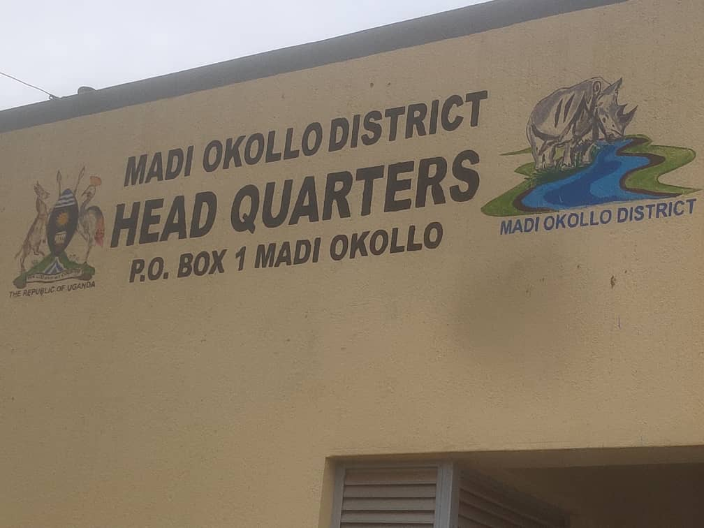
Field Photos
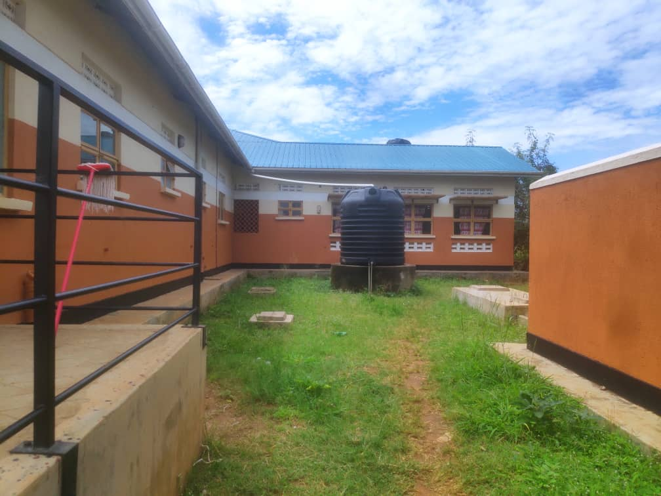
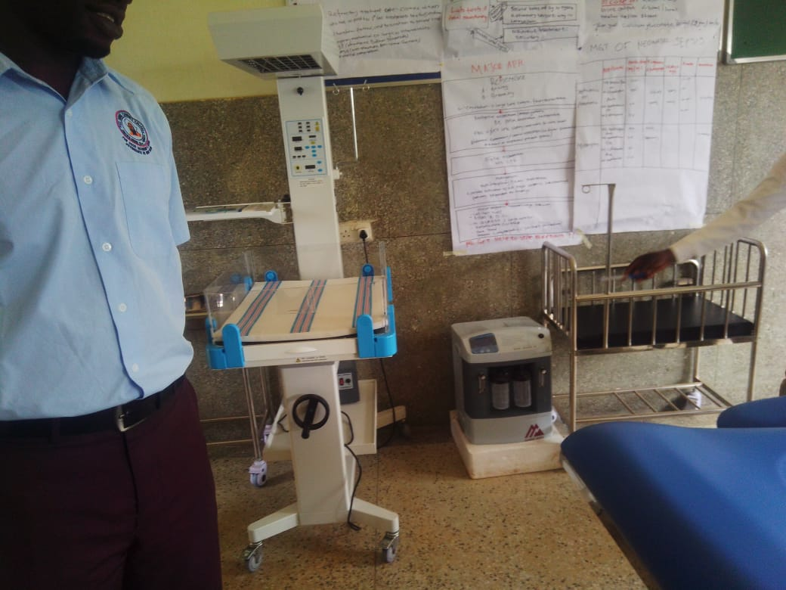

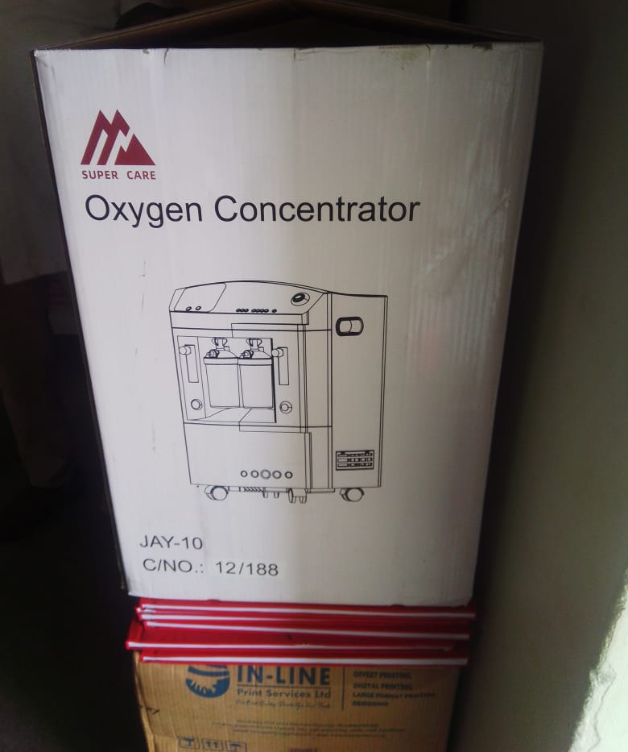

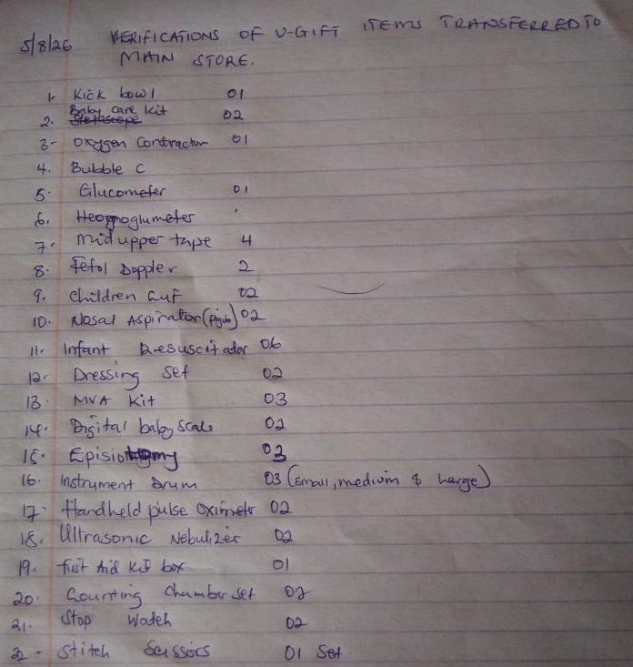
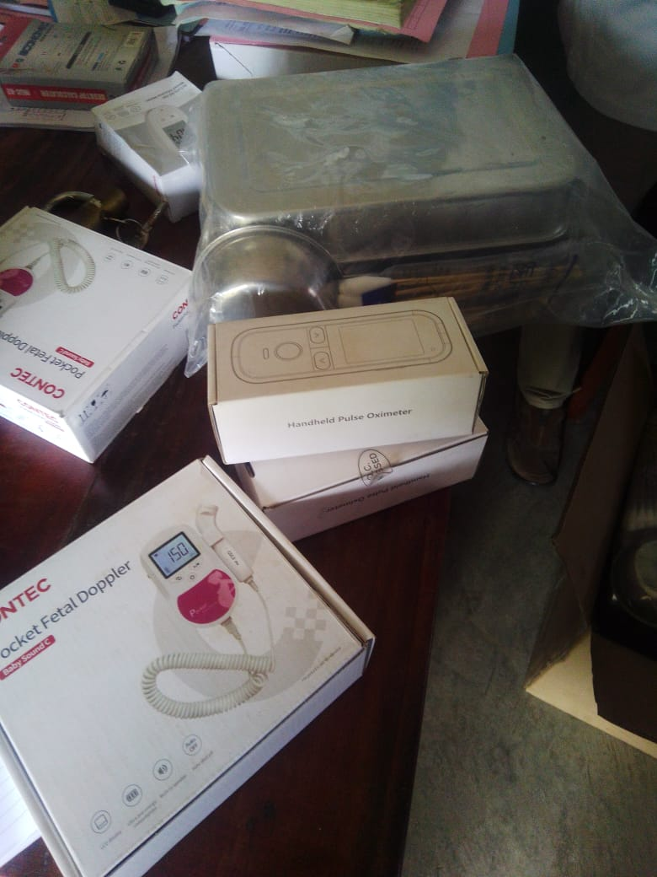
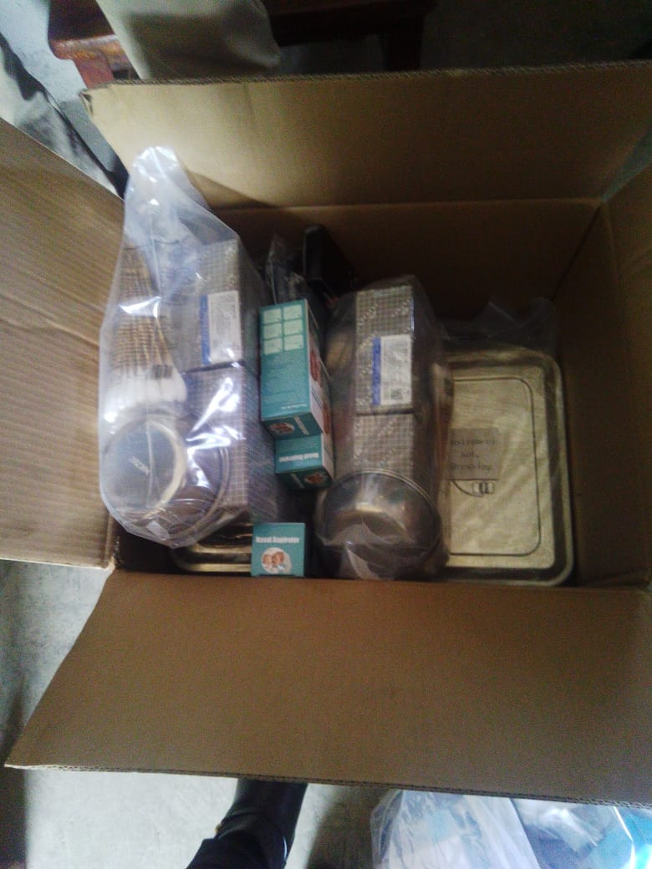
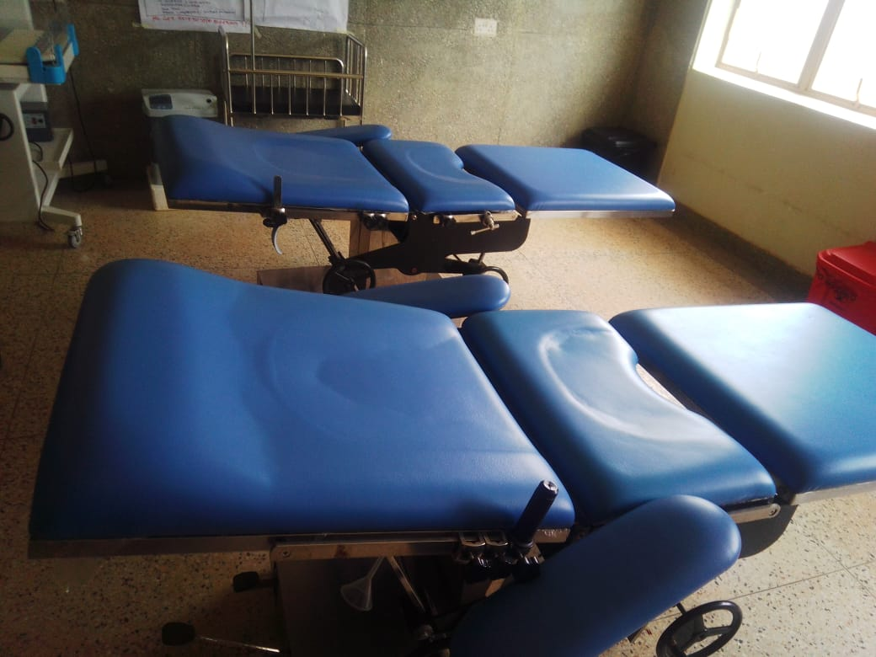
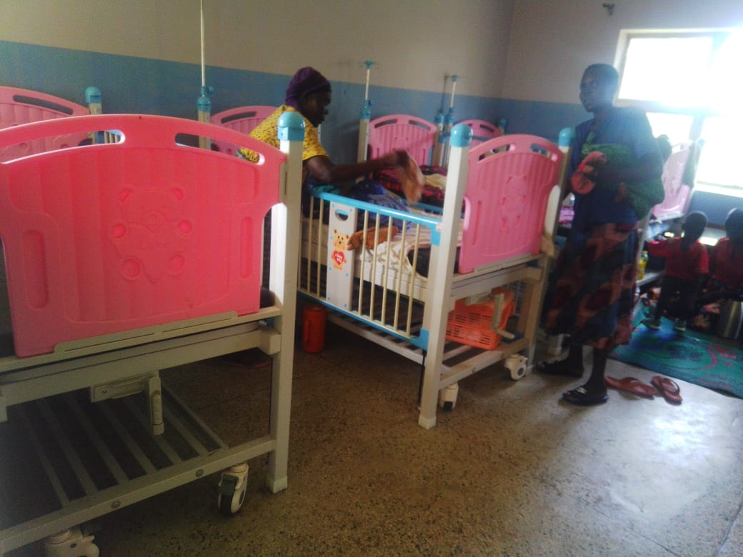

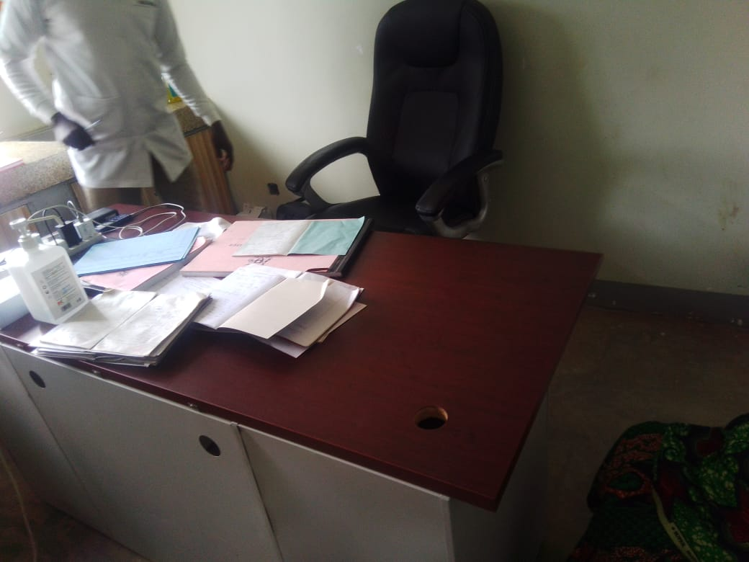

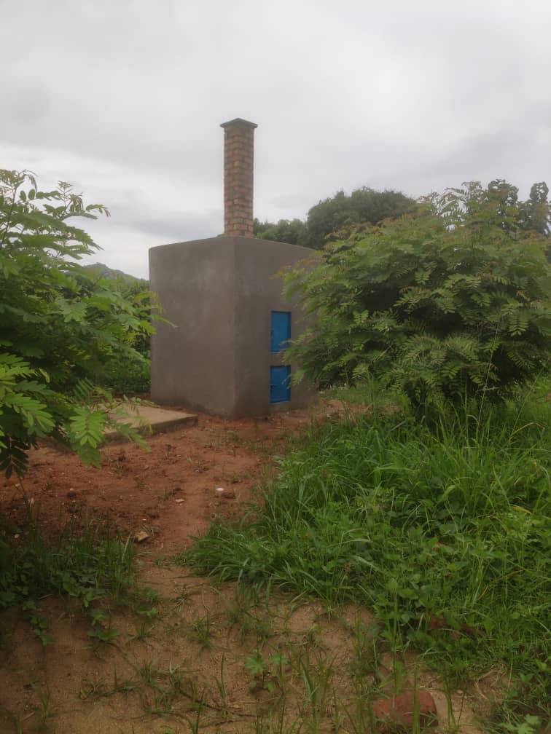

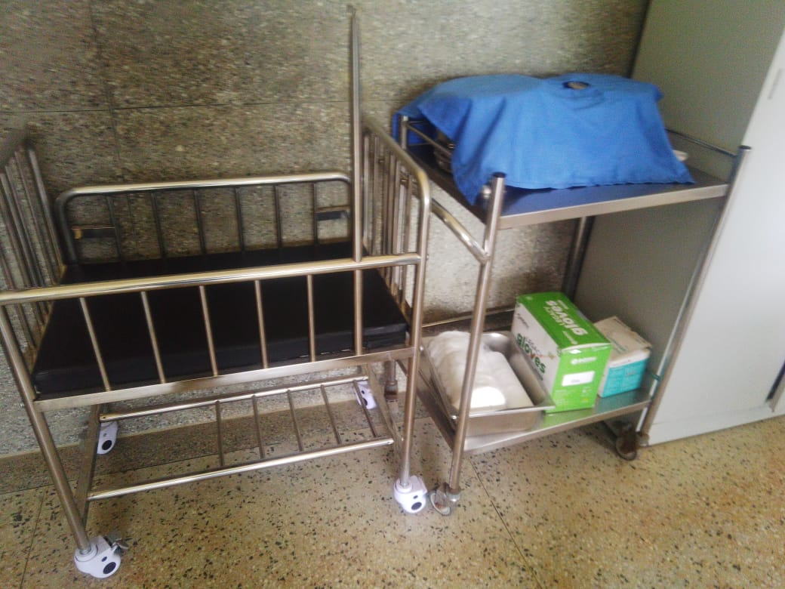

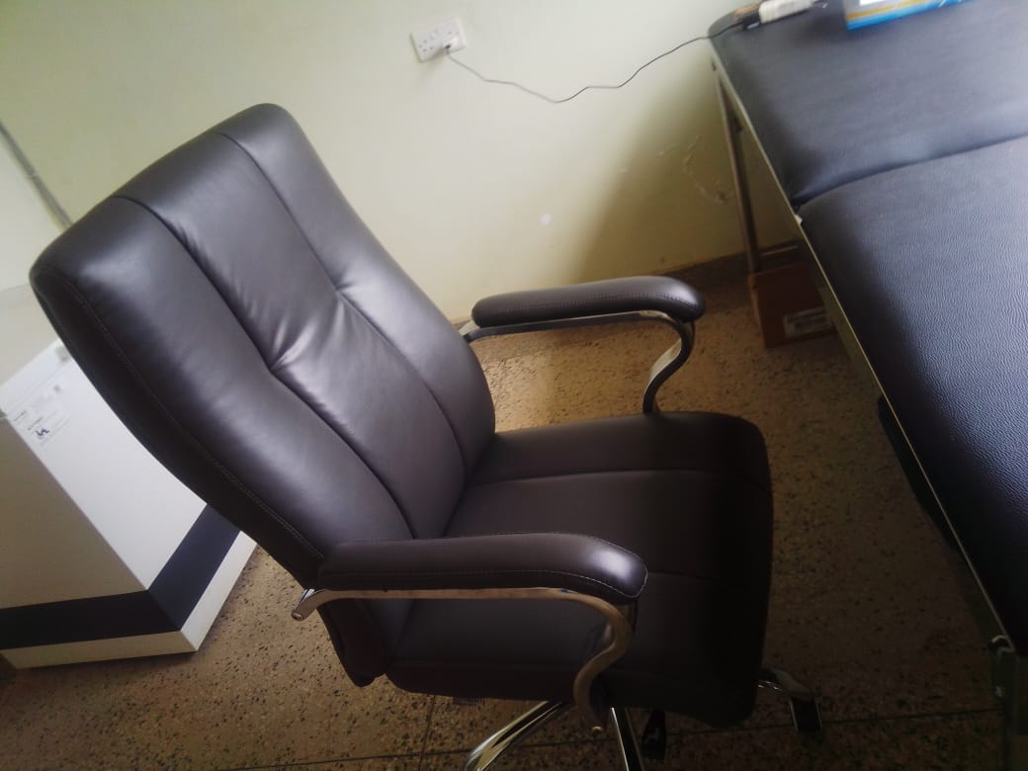
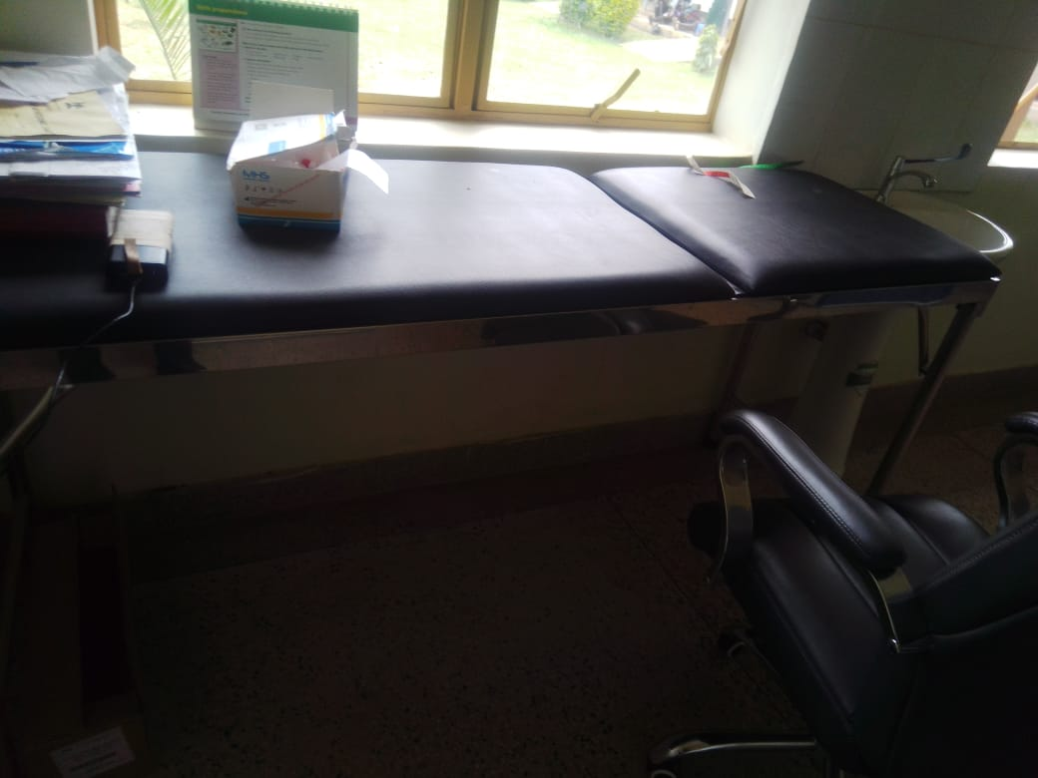

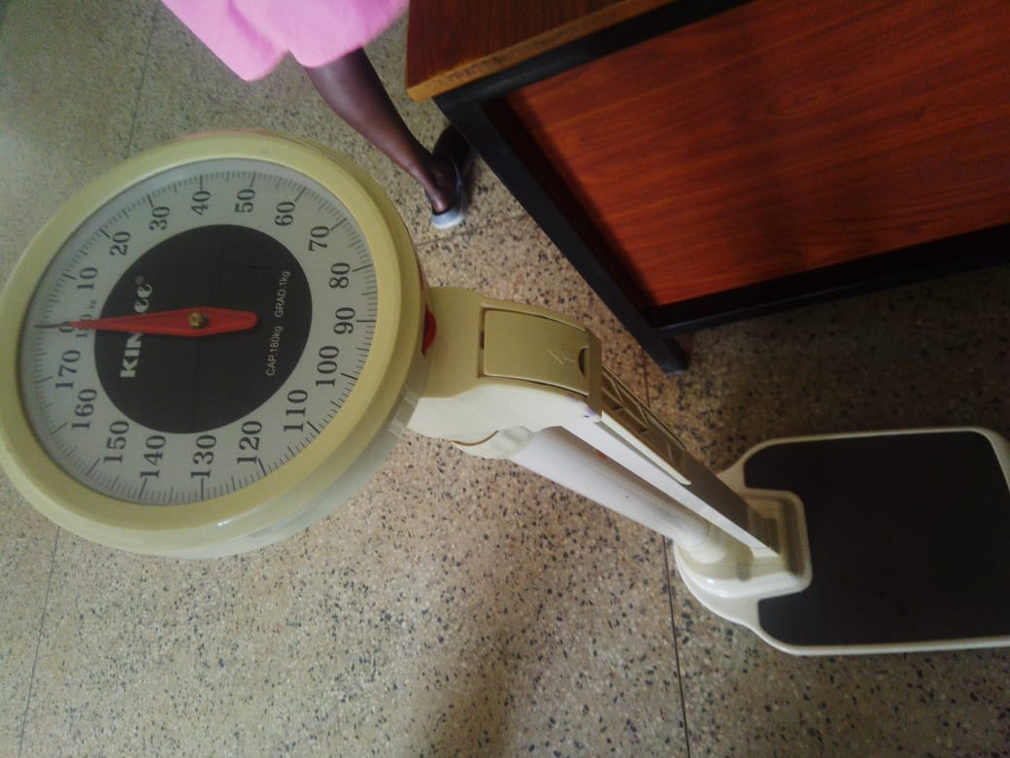
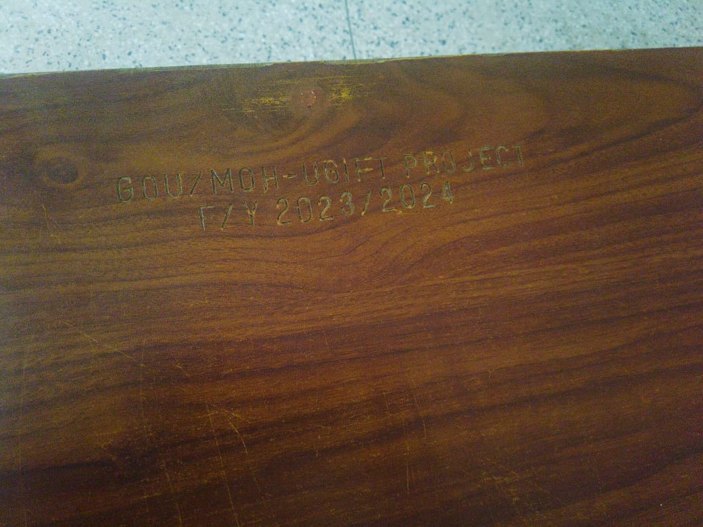

Report compiled by:
Isah Lukwago and Stella Male

